Business Vision

Project Name(Dajin Portal)
Business Requirements Document (BRD)

Prepared by: Business Vision
Prepared for: Dajin Portal
Date Submitted: [Date]

Last Updated:30 August 2021
Creation Date:

Table of Contents

Table of Contents 2
1. Introduction 3
1.1. Document Purpose 3
1.2. Intended Audience 3
1.3. Project Background 3
1.4. Purpose of the Business Requirements 3
1.5. Business Goals/Objectives to be achieved 3
1.6. Stakeholders 4
1.7. Dependencies on existing systems 4
1.8. References 4
1.9. Assumptions 4
2. Requirements Scope 4
2.1. In Scope 4
2.2. Out of Scope 5
3. Functional Requirements 5
3.1. Essential Use Case Diagram 5
Flow Charts 7
Farmer Registration Flow 7
Farm Registration 9
Farmer Login 11
Edit Farm Flow 13
Trusted Trader Registration Flow 15
Normal Trader Registration Flow 16
Trader Login 18
Purchase Order flow 20
Selling flow 22
6. Pending Issues ( Discussion ) 24
Revision Log 25
Approval 26

Introduction

Document Purpose

The purpose of this document is to describe business requirements of an application completely, accurately and unambiguously in Technology-independent manner. All attempts have been made in using mostly business terminology and business language while describing the requirements in this document. Very minimal and commonly understood technical terminology is used. Use case / Designer approach is used in modeling the business requirements in this document.

Intended Audience

The main intended audience for this document are the business owners of the proposed system. This document should be readable by business owners of the proposed system. They must be able to verify that their business requirements have been documented here completely, accurately and unambiguously.

Data Architects, Application Architects and Technical Architects would also find the information in this document useful when they need to design a solution that will address these business requirements.

Since the requirements are documented here in Technology-independent manner, the end-users of the system should be able to comprehend the requirements fairly easily from this document.

Project Background
Currently group of people monopolizing the poultry market this cause losses for the Farmers (المربيين) So we need to create actual market through our portal.

Purpose of the Business Requirements

This section describes the purpose of the Business Requirements.

Business requirements for new application development.

Business Goals/Objectives to be achieved

The major goals of the project is to:
- Create centralized portal for poultry market to maintain the market price, data, relationships.
- Contact the Farmers with the Traders
- Review and rating for the Farmers and Traders will enhance the buying process
- Market reports and insight.

Stakeholders

Stakeholders are the individuals or groups who have a vested interest in this project and whose interests need to be considered throughout the project. This section lists the Stakeholders of the Application / Project for which these Business requirements are documented.

- Business owners
- Customer support
- Architects

Dependencies on existing systems

N/A

References

N/A

Assumptions

This section describes major assumptions that were made prior to or during the Business Requirements gathering and documentation.

Requirements Scope

This section shows what business functionality is in scope and out of scope for Implementation.

In Scope

- Register new Farmers
- Farmers can register multiple Farms
- Normal Traders register from mobile
- Login ( Farmer , Trader , admin)
- Users can make forget password
- Traders make purchase order
- Farmers can confirm the selling date (متوقع تاريخ البيع)
- Farmers can edit price (السعر الاسترشاد)
- Farmers can accept or reject the purchase orders
- After the selling transaction done then Farmer should rate Trader
- After the buying transaction done then Traders should rate Farmer
- System calculate the loyalty points
- Admin register the trusted Traders
- Admin search on the profiles
- Admin can update the Farmers , Farms and Traders profiles
- Admin edit configuration like ( متوقع تاريخ البيع & السعر الاسترشاد )

Out of Scope
1.System to be connect to Payment GW
2. Convert from subscription type to another ( Silver to Gold)

Functional Requirements

Essential Use Case Diagram

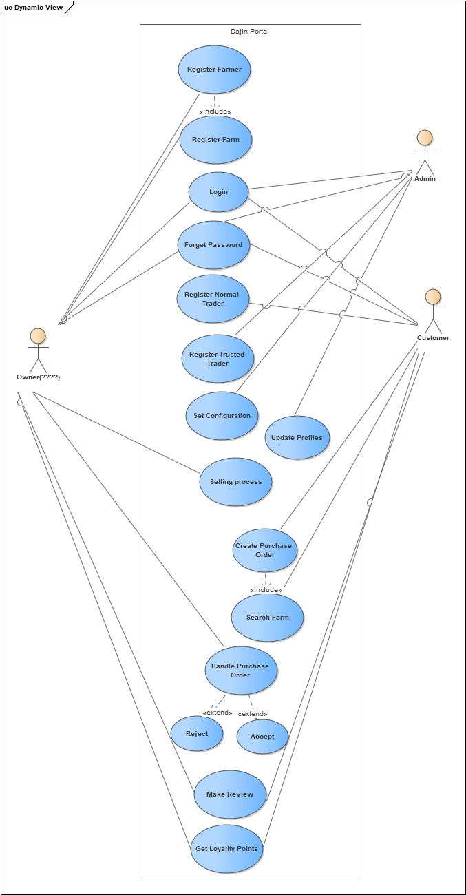

Flow Charts

Farmer Registration Flow
Description:

This Diagram describe the farmer registration flow from mobile or web application

Flow:
- Farmer register from Mobile/Web
- Profile save with pending on approval
- System send verification code on email or mobile
- Farmer enter verification code
- System verify the entered Code
- Farmer status should be Active
- Else Farmer can click resend activation

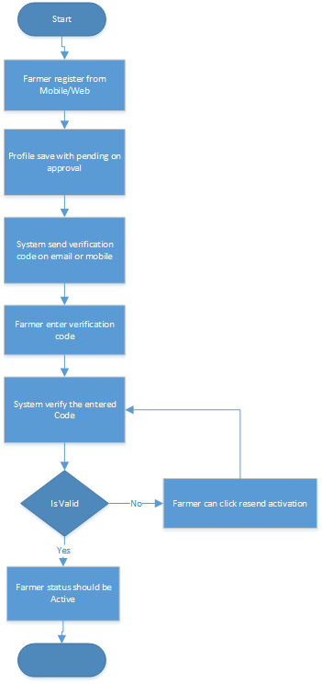

Farm Registration

Description:

This Diagram describe the farmer to register his Farms

Flow:
- Farmer click Register Farm
- Farmer enter Farm registration data
- System check if expected transaction date زمن البيع المتوقع للدورة الواحدة is valid against admin input per type
- If Not valid Display warning to Farmer and send notification to Customer support Team

- IF Valid then Check if the area is suitable for the type
- If Not valid Display warning to Farmer and send notification to Customer support Team

- System save Farm with status pending on approval
- Manual process from operation team to verify Farm data
- Trader support update Farm Status to Active
- Else Farmer can update Farm data again

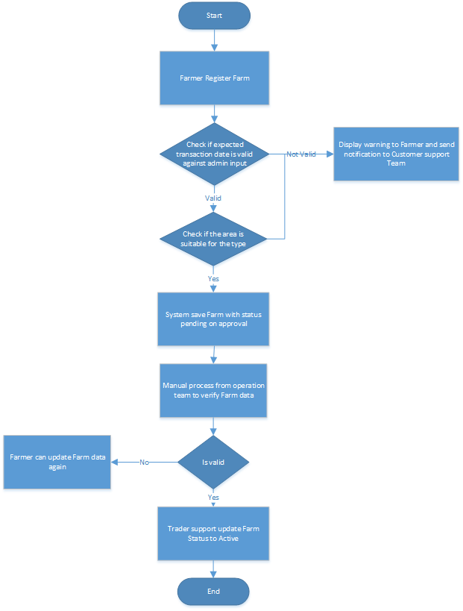

Farmer Login

Description:

This Diagram describe the farmer login process

Flow:
- Farmer Login to Mobile application
- System Check login credential
- If Not valid Login Failed please try again

- IF Valid then System Open Farmer Dashboard
- System check if the Farmer has any transaction without rating the Trader
- System display popup to Farmer to rate the Trader
- Did Farmer rate the Trader
- If no System prevent Farmer from making any Selling Process
- If yes System display if he has expected transaction date after X days
- Farmer should Confirm selling Date.
- If Farmer didn’t confirm then Farmer can update expected Date
- After confirming the expected selling date
- Then Farmer should confirm the Quantity offered for sale by choose one of the below
- Edit Quantity which offered for sale
- Confirm selling process
- Cancel Selling Process

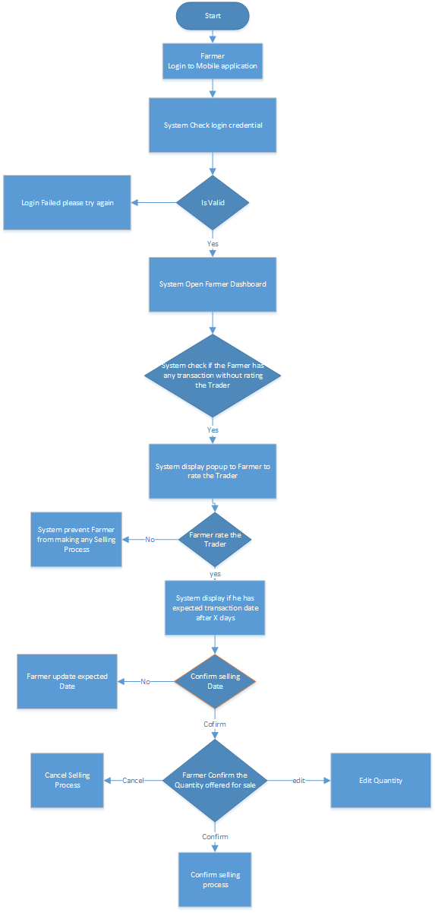

Edit Farm Flow
Description:

This Diagram describe the farmer edit the farm data.

Flow:
- Farmer open Farms Screen
- Open specific Farm which want to edit its data
- Some data will be configured in the system to be enable editing as ( نوع التربية , نوع التهوية, اسم العنبر)
- Else Some data will be configured in the system to be disable editing ( will be dimmed )
- In this case Farmer send visit request to customer support
- In case update data then System validate the mandatory
- Check if expected transaction date is valid against admin input
- If not valid Display warning to Farmer and send notification to Farmer support
- If valid then Check if the area is suitable for the type
- System save Farm Data

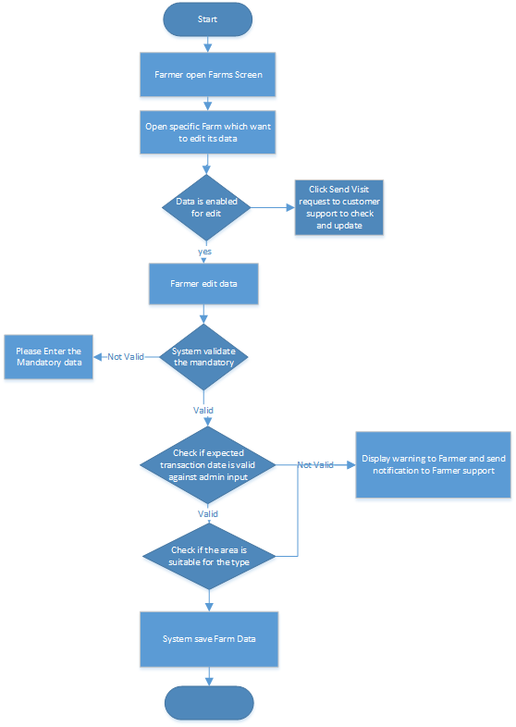

Trusted Trader Registration Flow
Description:

This Diagram describe the trusted trader registration flow. Trusted Trader are Traders very known Traders by operation team, so the operation will register them from the admin tool.

Flow:
- Admin register Trusted Trader data contain the Planned First Transaction date
- System will skip Trader verification step
- System save Trader status =”Active”
- Notification sent to Trader with user name and Password

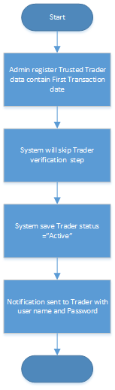

Normal Trader Registration Flow
Description:

This Diagram describe the normal trader registration flow. normal Traders are Traders who register from the mobile application or the web portal. The normal traders should choose x farms which deal with us from system or recommend X farms

Flow:
- Normal Trader registered from Web/ Mobile application
- System send verification code on email or mobile
- Farmer enter verification code
- System verify the entered Code
- If valid System request from Trader to enter X Farms which deal with it
- Trader search on farm by (Gov., Area, Farmer, Mobile No)
- Trader can make one of the below steps
- Select Farms from returned result
- Recommend Farms Data
- System Save Trader Profile with status Pending on Approval
- Admin review Trader Profile
- If Trader data valid
- Admin convert Trader status to Active
- System send notification to Trader that his account is active
- Else Admin convert Trader status to Inactive

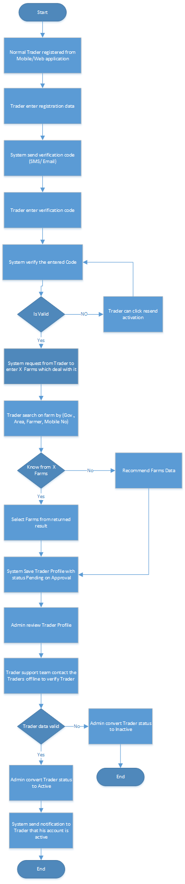

Trader Login

Description:

This Diagram describe the Trader login process

Flow:
- Trader Login to Mobile application
- System Check login credential
- If Not valid Login Failed please try again
- IF Valid then System Open Trader Dashboard
- System check if the Trader has any transaction without rating the Farmer
- System display popup to Trader to rate the Farmer
- IF Trader rate the Farmer
- If no System prevent Trader from making any purchase order
- If yes System display trader can accessing continue all system functions

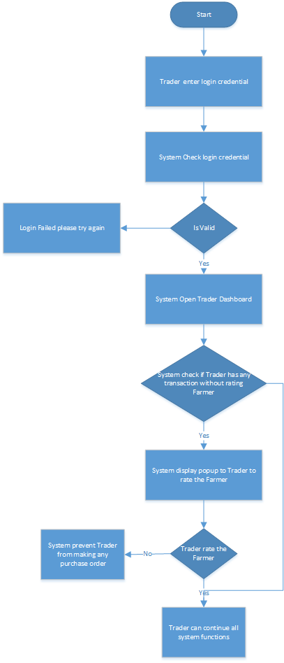

Purchase Order flow

Description:

This Diagram describe the purchase order process

Flow:
- Trader Login to Web /Mobile application
- Create Purchase Order by enter ( Gov., Type, Amount, Health Status, average weight, Price)
- Trader should enter price is in the range +-10%
- System Calculate the final price.
- Trader check if final price suitable
- Trader confirm purchase amount
- Else Trader update the amount in purchase order
- System display the matched Farms
- Trader choose Farm
- System hold quantity from Farm balance
- Farmer accept purchase order
- System Display the Farmer contact to Traders
- Else if farmer reject Notify Trader Please choose another Farmer
- Release the hold quantity
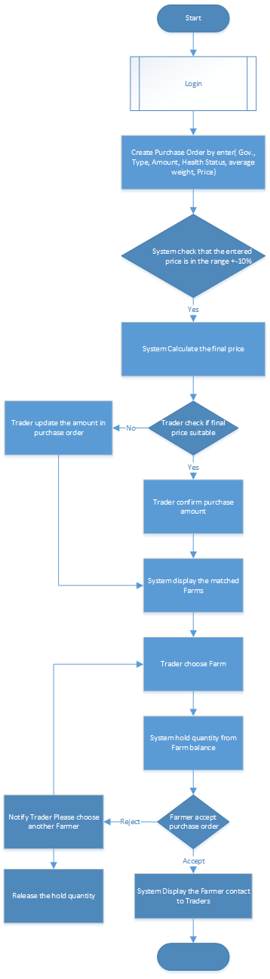

Selling flow

Description:

This Diagram describe the selling process

Flow:
- Farmer Login to Web /Mobile application
- Review Purchase Order ( Traders reviews, quantity )
- If Farmer accept Orders
- Amount holed from Total quantity
- Continue the transaction offline
- Farmer rate the Trader(quantity , confirm)
- Quantity Deducted from Total Quantity
- Else if farmer reject order
- System should notify trader “please select another trader”
- Release the hold quantity

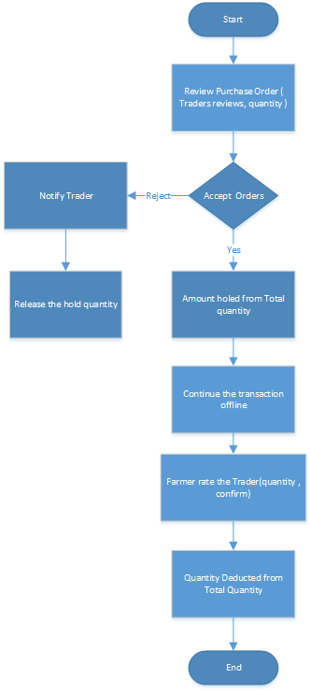

Pending Issues ( Discussion )
- Calculation of final price ( equation)

Revision Log

Date | Version | Change Reference | Reviewed by
[date]

Approval
This document has been approved as the official Business Requirements Document for the Project Name project.
Following approval of this document, changes will be governed by the project’s change management process, including impact analysis, appropriate reviews and approvals, under the general control of the Master Project Plan and according to Project Support Office policy.
Prepared by | Signature | Date
Author's Name
[Title]
[Organization]
Approved by | Signature | Date
[Client Acceptor’s Name]
[Title]
[Organization]

